Project Design Phase-I
Solution Architecture

Date | 08 OCT 2022
Team ID | PNT2022TMID42243
Project Name | Project – SMART SOLUTION FOR RAILWAYS
Maximum Marks | 4 Marks

Solution architecture is a complex process – with many sub-processes – that bridges the gap between business problems and technology solutions. Its goals are to:
● Find the best tech solution to solve existing business problems.
● Describe the structure, characteristics, behavior, and other aspects of the software to project stakeholders.
● Define features, development phases, and solution requirements.
● Provide specifications according to which the solution is defined, managed, and delivered.


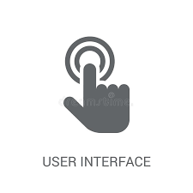







PASSENGER

TICKET EXAMINAR
WEB USER INTERFACE

WEB DEVELOPER
4.VERIFY
QR
CODE
4.LOCATION UPDATES AND OTHER ADDED FACIITIES

UWUUWFACILITES
2.BOOK TICKET
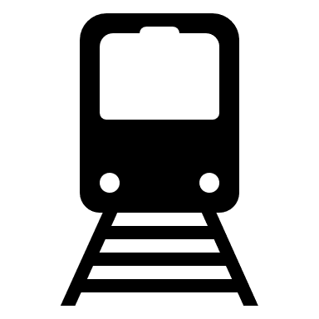

1.DEPLOY WEB APPLICATION
3.QR GENERATOR
IOT DEVICE

PYTHON CODE
CLOUD SERVICE

GPS MODULE
CLOUDANT DB
IBM WATSON IOT PLATFORM

